

**Instruction for Filling Funding Request Form Online**

* **Requirement:**
  + Electronic Copy of the Funding Request
  + A PDF Reader Application (Adobe Acrobat Reader, Foxit Reader, Nitro PDF Reader, ...)
* **Step 1:** 
  + Download the Funding Request Form as a PDF.
  + The file can be found on the Executive Board website (add link later)
* **Step 2:**
  + Open the PDF file using one of the application open above (do not use the browser because you cannot edit the PDF)
  + For this guide, we will be using Adobe Acrobat Reader
  + 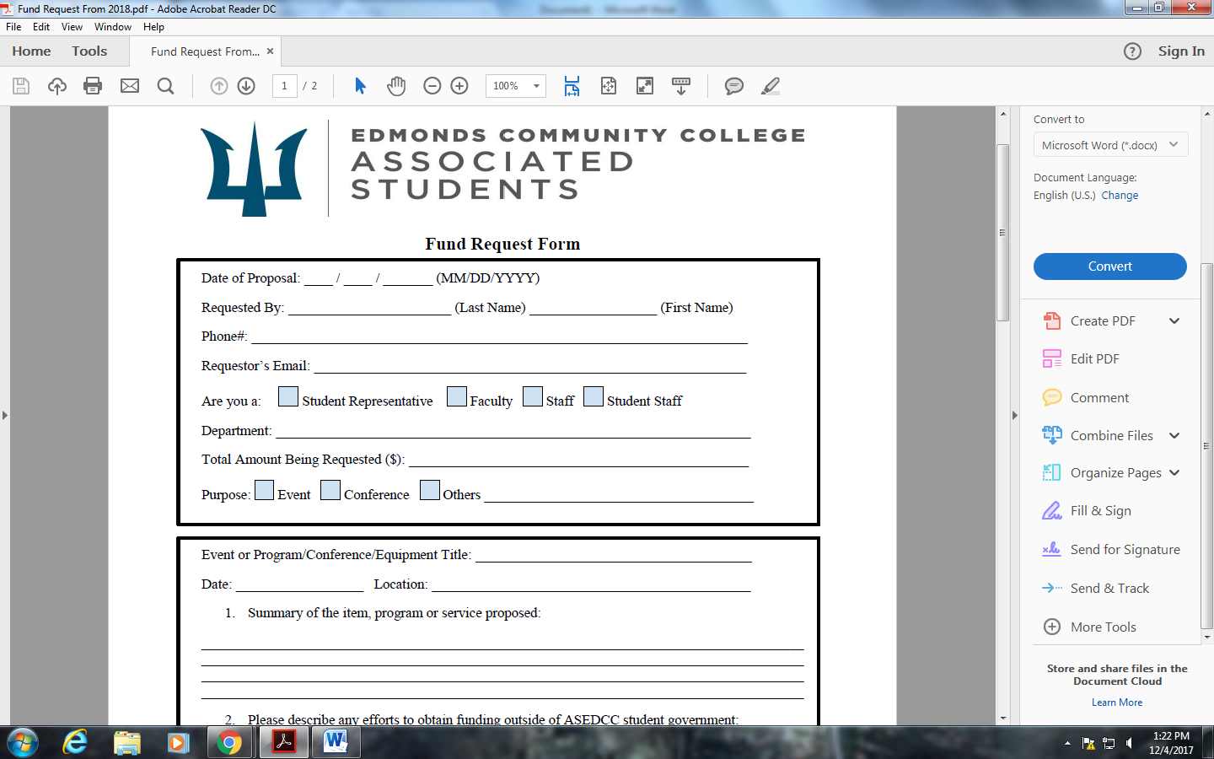Select the Fill & Sign Option in the options provided on the right

* Step 3:
  + Click on the field where you wish to input information, a text box will appear, please fill out the information
  + 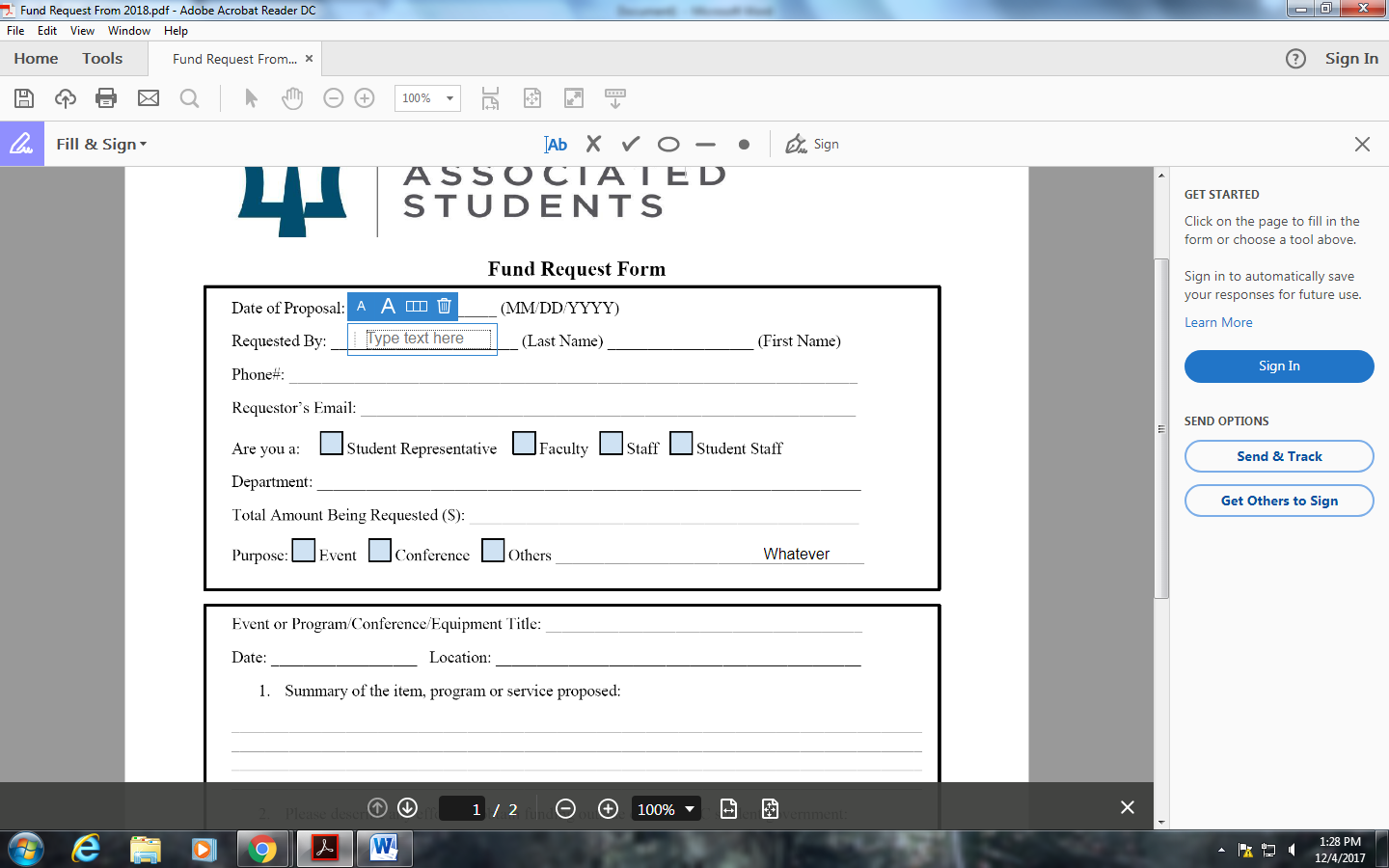Fill out the text box and continue to do so for the rest of the document
* Step 4
  + Save the new PDF
  + Send the file to asedc_assistant@email.edcc.edu
  + **IMPORTANT:** Your funding request must be submit 5 business days prior to the scheduled meeting for consideration. The Assistant to The Executive Board will send you an email to confirm your scheduled time for consideration. Failing to confirm the scheduled time will result in your request be move to the next meeting.   
    (*The Executive Board reserves the right to schedule your meeting at a later date, accept, or decline your request)*